**CENWP-OD-B 14 July 2023**

**MEMORANDUM FOR THE RECORD**

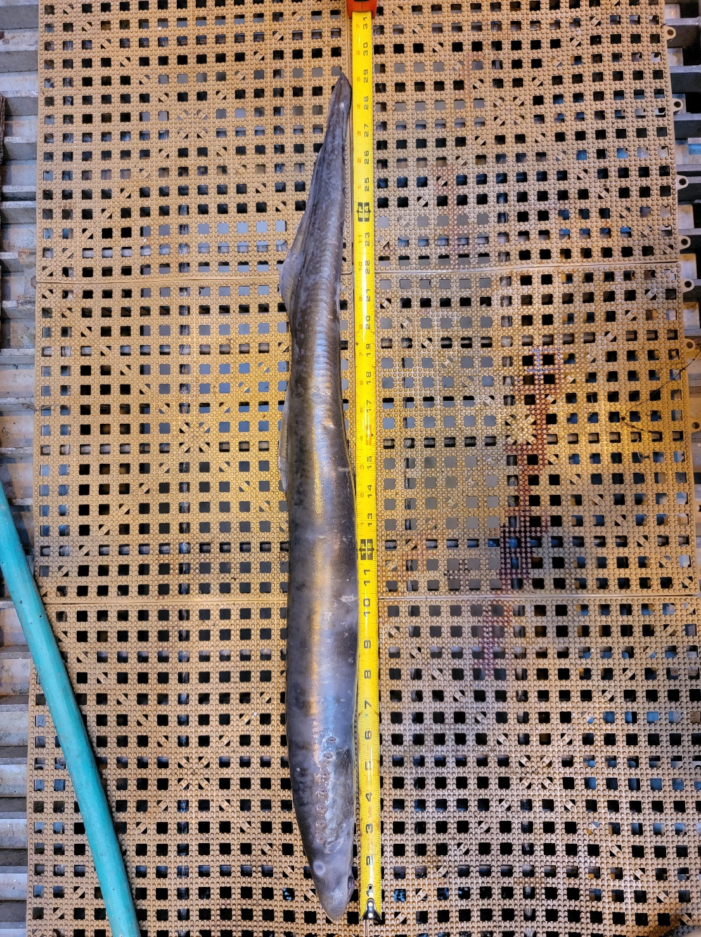**SUBJECT: 23BON057 MFR AFF Valve 15 Pacific Lamprey and Sockeye Mortalities**

On the morning of 14 July, Columbia River Inter-Tribal Fish Commission (CRITFC) Biologists notified Bonneville Project Biologists of one Pacific Lamprey mortalities and one smolt Chinook salmon found on the Valve 15 trash rack in the Adult Fish Facility (AFF). The fish were scanned for PIT tags, inspected, and returned to the river.

#1

1. Species – Pacific Lamprey (*Entosphenus tridentatus)*
2. Origin – Unknown
3. Length – 74.7 cm
4. Marks and tags – None
5. Marks and Injuries found on carcass – None
6. Cause and Time of Death – Unknown
7. Future and Preventative Measures – None

#2

1. Species – Sockeye Salmon (*Oncorhynchus nerka)*
2. Origin – Unknown
3. Length – 50.8 cm
4. Marks and tags – None
5. Marks and Injuries found on carcass – None
6. Cause and Time of Death – Unknown
7. Future and Preventative Measures – None

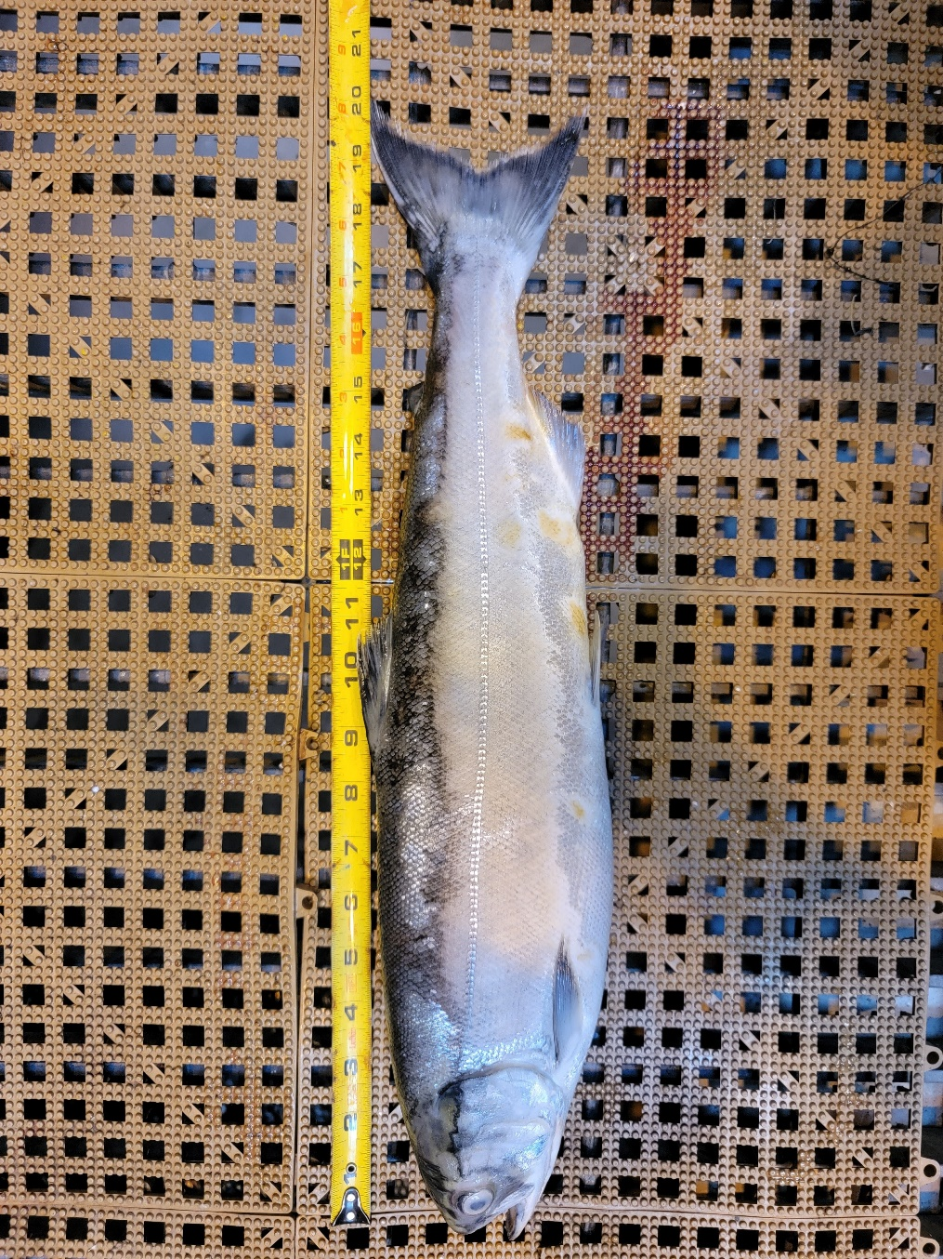

Sincerely,

Bonneville Project Fisheries